LABORATORY MANUAL
for
CHEMICAL ENGINEERING LAB I
(CHE F312)
CYCLE – Fluid Mechanics



DEPARTMENT OF CHEMICAL ENGINEERING
BIRLA INSTITUTE OF TECHNOLOGY & SCIENCE, PILANI
DUBAI CAMPUS, DIAC, DUBAI

TABLE OF CONTENTS
S. No. | Experiment Title
 | Verification of Bernoulli’s theorem
 | Discharge Over Notches
 | Fluid Friction in Pipes
 | Study of Flow Regimes by Osborn Reynold’s Apparatus
Calibration of Flow Measurement Devices
(Venturimeter, Orificemeter and Rotameter)
 | Air Flow Studies by Pitot Tube
 | Centrifugal Pump Test Rig

EXPERIMENT - 1
BERNOULLI’S THEOREM APPARATUS

1. OBJECTIVE:
To verify Bernoulli’s equation experimentally.

2. AIM:
- To calculate the total energy at different points and plot the graph between total energy at different points.
- Plot Graph between Total Energy (E) at the Different locations at Different Flow rates (Q).

3. INTRODUCTION:
Bernoulli’s theorem states that when there is a continuous connection between particles of flowing mass of liquid, the total energy at any section of flow will remain the same provided there is no reduction or addition of energy at any point.

4. THEORY:
Bernoulli’s equation is an energy equation and is based on the law of conservation of energy. This equation states that at two sections of flow field the total energy remains the same, provided that there is no loss or gain of energy between the two sections. This equation is valid only for steady flow. This equation is expressed as:
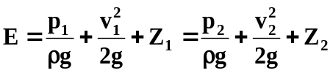
Where:
E = Total Energy.
p₁ = Pressure of fluid at point 1.
p₂ = Pressure of fluid at point 2.
V₁ = Velocity of fluid at point 1.
V₂ = Velocity of fluid at point 2.
p₁ / ρg = Pressure energy per unit weight of fluid or pressure head at point.
p₂ / ρg = Pressure energy per unit weight of fluid or pressure head at point.
V₁² / 2g = Kinetic energy per unit weight or kinetic head at point 1.
V₂² / 2g = Kinetic energy per unit weight or kinetic head at point 2.
Z₁ = Potential energy per unit weight of potential head at point 1.
Z₂ = Potential energy per unit weight of potential head at point 2.
ρ = Density of fluid.
g = Acceleration due to Gravity.
Pressure head is measured by piezometer tube, so
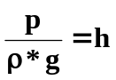
All the points are at same horizontal level, so potential head is constant for all points and can be taken as zero,
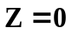
So Bernoulli’s Equation can be written as,
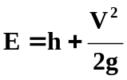
5. DESCRIPTION:
The present experimental set-up for Bernoulli’s Theorem is a self-contained re-circulating unit. The set-up accompanies the Sump tank, Constant Head Tank, Pump for water lifting, Measuring tank, etc. Control Valve is provided to regulate the flow of water in Constant Head Tank. A Test Section, made of Perspex, of varying cross section is provided, which has converging and diverging sections. Piezometer tubes are fitted on this test section at various points. The inlet of the Test Section is connected to constant head tank. At the outlet of Test Section, a valve is provided to regulate the flow of water through the test section. After achieving the steady state, discharge through test section can be measured with the help of measuring tank and stopwatch.

6. UTILITIES REQUIRED:
- Power supply: Single Phase, 220 Volts, 50 Hz, 5 Amp with Earth connection.
- Water Supply.
- Drain.

7. EXPERIMENTAL PROCEDURE:
Starting Procedure:
- Clean the apparatus and make all the tanks free from dust.
- Close the drain valves provided.
- Fill sump tank ¾ with clean water and ensure that no foreign particles are there.
- Close flow control valve given at the end of test section.
- Ensure that all On/Off Switches given on the panel are at OFF position.
- Now switch On the Main Power Supply (220 V AC, 50 Hz).
- Switch on the pump.
- Regulate flow of water through test section with the help of given gate valve at the end of test section.
- Measure flow rate using measuring tank and stopwatch.
Closing Procedure:
- When experiment is over, switch off pump.
- Switch off power supply to panel.
- Drain water from all tanks with the help of given drain valves.

8. SPECIFICATION:
Test Section : Material Acrylic.
Piezometer Tubes : Material P.U. Tubes (7 Nos.)
Water Circulation : FHP Pump.
Flow Measurement : Using Measuring Tank with Piezometer, Capacity 25 Ltrs.
Sump Tank : Capacity 100 Ltrs.
Inlet Tank : Capacity 28 Ltrs.
Stop Watch : Electronic.

9. FORMULAE:
1. Total Energy (E):
2. Velocity of Fluid (V):
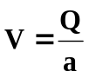m/s
3. Discharge (Q):
Q = m³/s

10. OBSERVATION & CALCULATIONS:
DATA: g = 9.81 m/s²
S. No. of Test points | Cross- Sectional Area  a (m²) | Distance from Reference point  S ( m)
1. | 6.1575 x 10⁻⁴ | 0.03
2. | 4.7143 x 10-4 | 0.07
3. | 3.463 x 10-4 | 0.11
4. | 2.405 x 10-4 | 0.15
5. | 1.539 x 10-4 | 0.19
6. | 2.405 x 10-4 | 0.23
7. | 3.463 x 10-4 | 0.27
8. | 4.7143 x 10-4 | 0.31
9. | 6.1575 x 10-4 | 0.35
OBSERVATION TABLE:
S. No. | Rotameter Reading (LPH) | h (cm)  At Piezometric Tube No.
S. No. | Rotameter Reading (LPH) | 1 | 2 | 3 | 4 | 5 | 6 | 7 | 8 | 9
1
2
3
4
CALCULATION TABLE (4 times):
Run No. =
Discharge = m³/s

Tube No. | 1 | 2 | 3 | 4 | 5 | 6 | 7 | 8 | 9
V (m/s)
p/ρg = h(m)
V²/2g

E

11. NOMENCLATURE:
a = Cross sectional area of test points, m².
E = Total Energy, kJ
g = Acceleration due to gravity, m/s²
h = pressure head in piezometer tubes, cm
p / ρg = Pressure energy per unit weight of fluid or pressure head.
Q = Discharge through test section (m³/s)
R = Rise of water level in Measuring Tank (m)
S = Distance of the points from reference point (m)
t = Time taken for R (s)
V = Velocity of fluid (m/s).
V² / 2g = Kinetic energy per unit weight or kinetic head, kJ
Z = Potential energy per unit weight of potential head, kJ

12. PRECAUTION & MAINTENANCE INSTRUCTIONS:
- Always keep apparatus free from dust.
- Always use clean water.
- Do not run the pump at voltage less than 180 Volts and above 230 V.

13. REFERENCES:
- Perry, R.H., Green, D. (editors), “Perry’s Chemical Engineers’ Handbook”, 6th ed., McGraw Hill, NY, 1985.

EXPERIMENT - 2
DISCHARGE OVER NOTCHES

1. OBJECTIVE:
To study the discharge over different types of notches.
2. AIM:
- To determine the co-efficient of discharge through different type of notches:
1) Rectangular Notch
2) V-Notch - 45º or 60°
- Plot Graph between Co-efficient of discharge (C_{d}) Vs Discharge (Q)
3. INTRODUCTION:
A notch is a device used for measuring the rate of a liquid flowing through a small channel or a tank. It may be defined as an opening in the side of a tank or a small channel in such a way that the liquid surface in the tank or channel is below the top edge of the opening. The sheet of water flowing through the notch is called Nappe or Vein. The bottom edge of a notch over which the water flows, is known as the sill or crest.
4. THEORY:
CO-EFFICIENT OF DISCHARGE:
The ratio of actual discharge over a notch to the theoretical discharge is known as co-efficient of discharge. Mathematically, Co-efficient of discharge:
C_{d} = 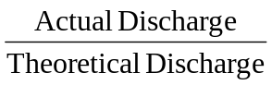
DISCHARGE OVER A RECTANGULAR NOTCH:
Q = 2/3 C_{d} L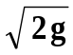 [H] ^{3/2}
DISCHARGE OVER TRIANGULAR NOTCH:
Q = 8/15 C_{d} tan θ/ 2 [H] ^{5/2}
5. DESCRIPTION:
The apparatus is designed to demonstrate the notch experiments and to find the co-efficient of discharge. A set of three knife edged notch plates made up of brass sheet is provided. One of them is rectangular others are ‘V’ notch having angles 60° and 45°. The notches are interchangeable. A pointer is provided to measure the height of water level over the crest of the notch.
6. UTILITIES REQUIRED:

Power supply: Single Phase, 220 Volts, 50 Hz, 5 Amp.
Water Supply (Initial fill approx. 80 litres).
Drain Required.

7. EXPERIMENTAL PROCEDURE:

Starting Procedure:
1. Clean the apparatus and make all three tanks free from dust.
2. Close the drain valves provided.
3. Close Flow Control Valve given in water line.
4. Open By-Pass Valve.
5. Fix desired Notch on the flow channel.
6. Fill Sump tank ¾ with clean water and ensure that no foreign particles are there.
7. Ensure that all On/Off Switches given on the panel are at OFF position.
8. Now switch on the Main Power Supply (220 V AC, 50 Hz).
9. Switch on the pump.
10. Allow water to flow through channel by opening flow control valve.
11. Close control valve when water coming out through the notch.
12. Measure the crest height, i.e., height of water in the channel at no flow condition.
13. Regulate Flow of water through channel with the help of given Flow Control Valve.
14. Record the height of water level in the channel with the help of pointer Gauge.
15. Measure Flow Rate using Measuring Tank and Stop Watch.

Closing Procedure:
1. When experiment is over, Switch off pump.
2. Switch off Power Supply to panel.
3. Drain water from all three tanks with the help of given drain valves.
8. SPECIFICATION:
Channel Test Section : Size 1000 x 230 x 160 mm.
Notches : Material Brass (3 Nos.)
1. Rectangular Notch
2. 45° V Notch
3. 60° V Notch

Pointer Gauge : With scale
Water Circulation : FHP Pump.
Flow Measurement : Using Measuring Tank with Piezometer.
Sump Tank : Capacity 100 Litres (approx.)

9. FORMULAE:
1. Actual discharge,
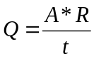 (1)
- Water head above Crest,
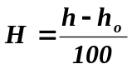 m
3. Discharge over Rectangular Notch,
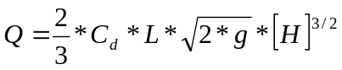
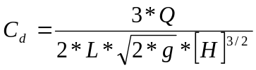 (2)

4. Discharge over Triangular Notch,
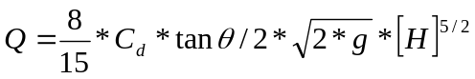
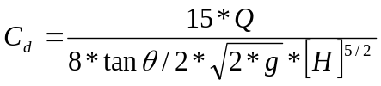 (3)

10. OBSERVATIONS & CALCULATIONS:
DATA:
RECTANGULAR NOTCH:
Width (L) = 30 mm = 0.03 m
Depth = 80 mm = 0.08 m

OBSERVATIONS:
Crest height, h_{o} = ______ cm
S. No. | Water head h (cm) | Rise of water level in measuring tank (cm) |  | Time for R, t ( sec )
S. No. | Water head h (cm) | Initial height R1(cm) | Final height R2(cm) | Time for R, t ( sec )
1
2
3
4

CALCULATION TABLE:
S. No. | Water head over crest H (m) | Rise in water in tank R=R2-R1 (m) | Q (m³ /s) | C _{d}
1
2
3
4

V-NOTCH:
Depth = 80 mm. = 0.08 m

Angle of notch = 45⁰, 60⁰

Area of measuring tank = 0.1 m²

OBSERVATIONS:
Crest height, h_{o} = ______ cm
S. No. | Water head h (cm) | Rise of water level in measuring tank (cm) |  | Time for R, t ( sec )
S. No. | Water head h (cm) | R1 | R2 | Time for R, t ( sec )
1
2
3
4

CALCULATION TABLE:

S. No. | Water head over crest H (m) | Rise in water in tank R=R2-R1 (m) | Q (m³ /s) | C _{d}
1
2
3
4

11. GRAPH:

Draw a graph between flow rate & C_{d} for all the notches

12. NOMENCLATURE:
A = area of measuring tank, m²
C _{d} = Co-efficient of discharge.
H = water head over crest, m
L = width of the rectangular notch, m
Q = actual discharge in m³/s
R = Rise of water level in measuring tank, m.
t = Time for R (sec)
θ = angle of V- notch.

12. PRECAUTIONS & MAINTENANCE INSTRUCTIONS:
- Never switch on main power supply before ensuring that all the on/off switches given on the Panel are at OFF position.
- Never fully close the Delivery and By-pass line valves simultaneously.
- Always keep apparatus free from dust.
- Always use clean water.
13. REFERENCES:
- Streeter, V.L., Wylie, E.B., “Fluid Mechanics”, 1st ed., pp. 357-362, McGraw Hill, NY, 1983.
- Garde, R.J., “Fluid Mechanics through Problems”, 2nd ed., pp. 139-140, New age International, ND, 1997

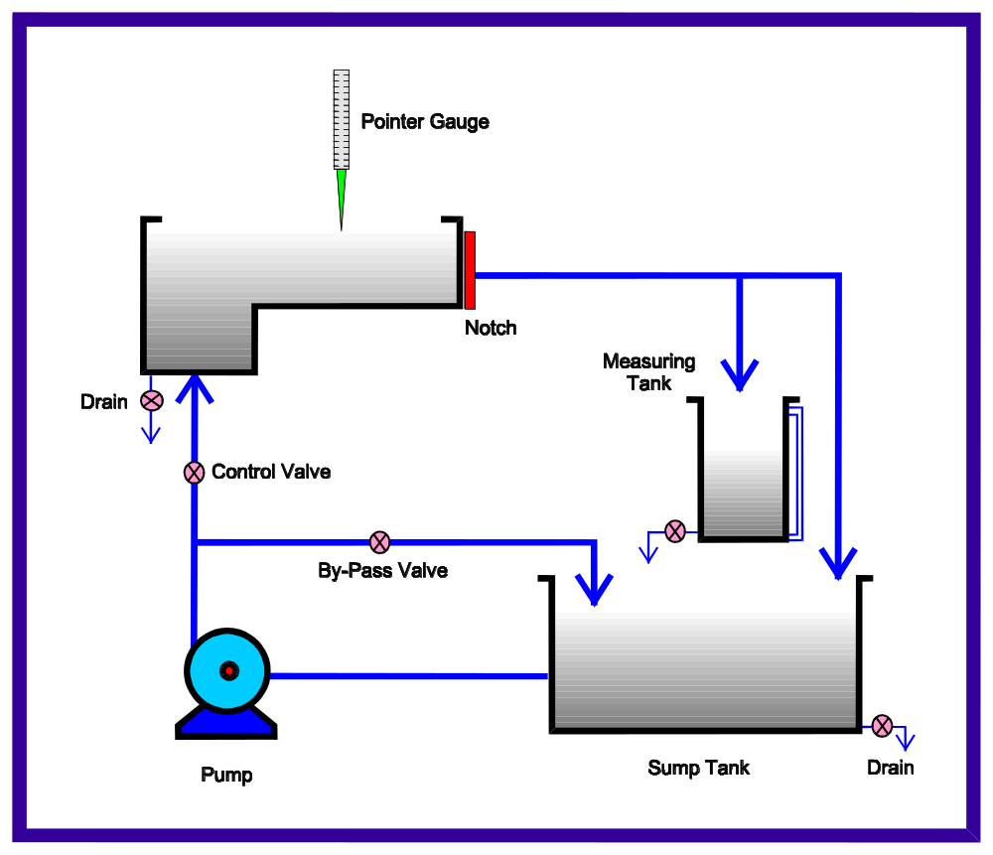

EXPERIMENT – 3

DETERMINATION OF LOSS COEFFICIENTS FOR PIPE FITTINGS (MINOR LOSSES)
1. OBJECTIVE:
To study the loss of head in pipe fittings at the various water flow rates.
2. AIM:
To determine the loss co-efficient for different pipe fittings (expansion, contraction, 45 degree bend and 90 degree bend). Compare your results with theoretical predictions.

3. INTRODUCTION:
Loss of head due to change in cross-section, bends, elbows, valves and fittings of all types fall into the category of minor losses in pipe lines. In long pipe lines, the friction losses are much larger than these minor losses and hence the latter are often neglected. But in shorter pipelines their consideration is necessary for the correct estimate of losses.

4. THEORY:
When there is any type of bend in pipe, the velocity of flow changes, due to which the separation of the flow from the boundary and also formation of eddies, takes place. Thus the energy is lost. The losses of head due to bend in pipe:
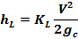
The minor losses in contraction can be expressed as:
The minor losses in enlargement can be expressed as:
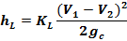
Theoretically, the loss coefficients can be estimated as follows
Expansion:
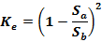

Contraction
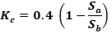
Here, is the cross-sectional area of smaller pipe and is the cross sectional area of the bigger pipe.
For 45 degree and 90 degree bends, the loss coefficient is reported to be around 0.2. Compare your results with these theoretical values and commend on it.

5. DESCRIPTION:
The apparatus consist of 17mm bend and elbow, a sudden expansion from 8mm to 17mm, sudden contraction from 17mm to 8mm, 17mm ball valve and gate valve. Pressure tappings are provided at inlet and outlet of these fittings at suitable distance. A differential manometer fitted in the line gives pressure loss due to fittings. Supply to the pipeline is made through centrifugal pump, which deliver water from sump tank. The flow of water in pipeline is regulated by means of a valve. Discharge is measured with the help of measuring tank and stopwatch.

6. UTILITIES REQUIRED:
Electric Supply: Single Phase, 220 Volts, 60 Hz, 5 Amp.
Water Supply (Initial Fill approx 70 ltrs).
Drain Required.
Floor Area Required: 2 m x 1 m

7. EXPERIMENTAL PROCEDURE:
Starting Procedure:
- Close the drain valve provided on the sump tank.
- Fill Sump tank ¾ with clean water and ensure that no foreign particles are there.
- Close all Flow Control Valves given on the water line and open by-pass Valve.
- Close all pressure taps of manometer connected to different pipe fittings.
- Ensure that On/Off Switch given on the Panel is at OFF position.
- Fill manometric fluid in the manometer.
- Now switch on the main power supply.
- Switch on the pump.
- Operate valve to regulate the flow of water in the desired Test Section.
- Open the pressure taps of Manometer of related test section, very slowly to avoid the blow of water on manometer fluid.
- Now open the air release valve provided on the manometer, slowly to release the air from manometer.
- When there is no air in the manometer, close the air release valves.
- Adjust water flow rate in desired section with the help of control valve.
- Record the manometer reading.
- Measure the flow of water, discharged through desired test section, using stopwatch and measuring tank.
- Repeat same procedure for different flow rates of water, operating control valve and by-pass valve.
- Repeat same procedure for different test sections.

Closing Procedure:
- When experiment is over, close all Manometers Pressure Taps first.
- Switch off pump.
- Switch off power supply to panel.
- Drain all the tanks.

8. SPECIFICATION:
Sudden Enlargement : From 8mm to 17mm
Sudden Contraction : From 17mm to 8mm.
Bend : 17mm
Elbow : 17mm
Ball valve : 17mm
Gate valve : 17mm
Water Circulation : Pump 0.5 HP.
Flow Measurement : Using Volumetric Measuring Tank & Stop Watch.
Sump Tank : Capacity 50 Litres.
Standard make On/Off Switch, Mains Indicator, etc.
All tanks are made of Stainless Steel.
The whole set-up is well designed and arranged in a good quality painted structure
9. FORMULAE:
1. Discharge:
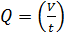
R = (R1-R2)/1000 m³
2. Velocity:
3 Loss of head,
H_{L} = 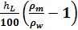 m of Water
4 Loss Coefficient (for Contraction):
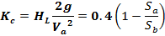
5 Loss Coefficient (for Expansion):
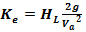=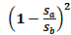
Here, Va is the velocity through the smaller pipe, Sa and Sb and area of smaller and larger pipes, respectively.
6 Loss Co-efficient for pipe fittings:
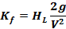

10. OBSERVATION & CALCULATIONS:
DATA:
ρ_{m} = 13600 kg/m³
ρ_{w} = 1000 kg/m³
g = 9.81 m/sec²
d₁ = 0.008 m.
d₂ = 0.017 m.
a₁ = 5.026 x 10⁻⁵ m²
a₂ = 2.27 x 10⁻⁴ m²

OBSERVATION TABLE (Contraction)
S. No. | R  liter | t  sec | h_{L}  cm of Hg
1
2
3
4
OBSERVATION TABLE (Expansion)
S. No. | R  liter | t  sec | h_{L}  cm of Hg
1
2
3
4
OBSERVATION TABLE (45 degree Bend)
S. No. | R  liter | t  sec | h_{L}  cm of Hg
1
2
3
4

OBSERVATION TABLE (90 degree Bend)
S. No. | R  liter | t  sec | h_{L}  cm of Hg
1
2
3
4
CALCULATION TABLE: (Contraction)
S. No | Q  m³/s | V₁  m/s | V₂  m/s | H_{L}  m of water | K _{L}
1
2
3
4
CALCULATION TABLE: (Expansion)
S. No | Q  m³/s | V₁  m/s | V₂  m/s | H_{L}  m of water | K _{L}
1
2
3
4
CALCULATION TABLE: (45 degree bend)
S. No | Q  m³/s | V₁  m/s | V₂  m/s | H_{L}  m of water | K _{L}
1
2
3
4

CALCULATION TABLE: (90 degree bend)
S. No | Q  m³/s | V₁  m/s | V₂  m/s | H_{L}  m of water | K _{L}
1
2
3
4

11. NOMENCLATURE:
a₁ = Cross-sectional area of Small Dia. Pipe, m².
a₂ = Cross-sectional area of Large Dia. Pipe, m².
d₁ = Diameter of small pipe, m
d₂ = Diameter of small large pipe, m
g = Acceleration due to gravity, m/s².
h_{L} = Head loss, m of water.
K_{L} = Loss coefficient.
Q = Discharge, m³/s.
R = Rise of water level in measuring tank, liter.
R₁ = Final height of water in measuring tank after time t, liter.
R₂ = Initial height of water in measuring tank, liter.

t = Time taken for R (sec).

V₁ = Velocity of fluid in pipe of Small Diameter, m/s.

V₂ = Velocity of fluid in pipe of Large Diameter, m/s.

12. PRECAUTION & MAINTENANCE INSTRUCTIONS:
- Do not run the pump at Voltage less than 180 and above 230 Volts.
- Never fully close, the Delivery line and By-Pass line Valves simultaneously.
- Always keep apparatus free from dust.
- To prevent clogging of moving parts, Run Pump at least once in a fortnight.
- Always use clean water.

13. TROUBLESHOOTING:
- If pump gets jam, open the back cover of pump and rotate the shaft manually.
- If pump gets heat up, switch off the main power for 15 minutes, avoid closing the flow control valve, and by pass valve simultaneously during operation also check main supply, it should be in the specified range.

14. REFERENCES:
Modi P.N., Seth S. M., “Hydraulics And Fluid Mechanics Including Hydraulics Machines”, 15th ed., 2005, pp 370- 376.

EXPERIMENT - 4

OSBORNE REYNOLDS’ APPARATUS

1. INTRODUCTION:
British Engineer Osborne Reynolds (1883) investigated the transition between laminar and turbulent flow regimes in a circular tube. He formulated the dimensionless parameter that later was named after him-the Reynolds’ Number.
At low fluid velocities, the fluid moves without lateral mixing, as though a series of concentric conduits are sliding into one another without macroscopic mixing. In such a flow, the streamlines (defined as imaginary lines in a mass of flowing fluid lying in the direction of flow and across which no fluid flows) remain distinct from one another over the entire length. This type of flow is called Laminar, Viscous or Streamline Flow.
At high fluid velocities, eddies forms in the fluid under motion causing lateral mixing and superimposition of turbulence on the primary motion of translation, thus disrupting the flow pattern. This type of flow is called Turbulent Flow and is more commonly encountered in engineering system.
One way to determine if a flow is Laminar or Turbulent is by flow visualization. Osborne Reynolds performed a series of systematic experiments in which water from a constant-head tank flowed through a clear tube. He injected a thin stream of dye into the flow. In Laminar flow, the dye remained in a thin filament. There was little dispersion of dye, except for slow molecular action. In Turbulent flow, the dye stream dispersed quickly into myriad entangled threads.

Laminar Flow Transition Turbulent Flow

Reynolds’ sketches of transition are shown here. The sketch at the upper left is Laminar Flow. The one on right represents Turbulent flow. Transition between these flow regimes covers a spectrum of intermediate states. Reynolds’ sketch of Transition is at middle.
The appearance of the jet leaving the end of the tube also varies with flow regime. The jet is steady and has a smooth, glassy appearance when flow in the tube is Laminar. (there also may be sheet of low-energy liquid from near the wall in a Laminar Jet.) This image shows the jet from the exit for a laminar flow.
When flow in the tube is turbulent, the jet has a pulsating character and a lumpy surface. Turbulent velocity fluctuations within the flow cause the lumpiness and surface irregularities. This shows the jet from a turbulent flow.
Numerous factors are important in the process of transition from laminar to turbulent flow in a pipe, including flow speed, pipe diameter, fluid density, inlet conditions, pipe roughness, and system vibration.
For a given system and fluid, pipe diameter, fluid properties, inlet conditions, and pipe roughness are fixed. This leaves flow speed and system vibration under the control of the experimenter.
Reynolds used a smooth tube with a rounded entrance. He found from his experiments that the flow speed and pipe diameter could be combine with the fluid density and viscosity to form a dimensionless parameter which is now called Reynolds’ Number.

Theory
Fluid flow can be characterized as laminar, turbulent, or transitional. The dimensionless Reynold's number (Re) can be used to determine the fluid flow condition. The Reynold's number is defined as
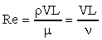
Where
ρ = The fluid density,
V = The velocity of the fluid,
L = An important length dimension for the flow
= D (Internal Diameter of Pipe)
μ. = The dynamic viscosity, and
ν = The kinematic viscosity

For pipe flow, L is taken as the pipe diameter (D). Re can be interpreted as the ratio of the flow's inertial forces to its viscous forces. For large viscous forces (low Re, normally Re < 2000 for pipe flows), viscous effects are great enough to damp any disturbances or perturbations in the flow and the flow remains laminar. Any combination of low velocity, small diameter, or high kinematic viscosity which results in Re < 2000 for pipe flow will produce laminar flow. The flow is called "laminar" because the flow takes place in layers. The only mixing that occurs is molecular mixing between the layers or between different parts of the flow. For large inertial forces (large Re, normally Re > 4000 for pipe flows), there is not enough viscous damping to remove disturbances in the flow. Again, any combination of V, D, and ν giving Re > 4000 will produce turbulent flow.
As Re increases, the viscous damping of flow disturbances or perturbations decreases relative to the inertial effects. Because of a lack of viscous damping, disturbances are amplified until the entire flow breaks down into in irregular motion. There is still a definite flow direction, but there is an irregular motion superimposed on the average motion. Thus, for turbulent flow in a pipe, the fluid is flowing in the downstream direction, but fluid particles have an irregular motion in addition to the average motion. This effect is illustrated by the pathlines in Fig. 1; pathlines give a Lagrangian description of flow. The turbulent fluctuations are inherently unsteady and three-dimensional.
As a result, particles, which pass though a given point in the flow, do not follow the same path in turbulent flow even though they all are flowing generally downstream.

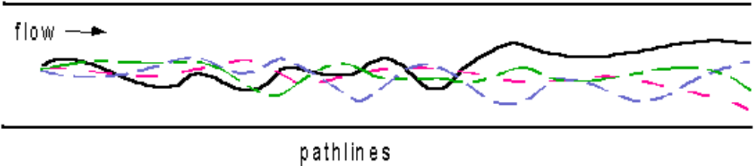
Fig. 1 - Lagrangian pathlines in turbulent flow
Since the velocities of all fluid particles are continually changing, the Eulerian velocities at a point or at several points are also changing. This effect is shown in the next two figures. Fig. 2 shows the time averaged velocity distribution across a diameter of a pipe and then illustrates the unsteadiness in the turbulent components of the velocities. Fig. 3 shows the time-averaged velocity at a point and the continual variation of instantaneous velocity due to the turbulent fluctuations.

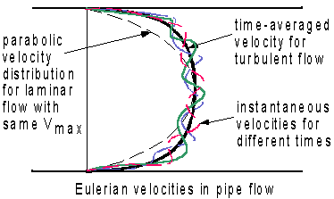

Fig. 2 - Eulerian velocity distributions at different times
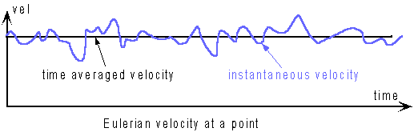

Fig. 3 - Time history of Eulerian velocity at a point

The instability or unsteadiness in turbulent flows is sometimes viewed as being due to parcels of fluid that are rotating in an irregular fashion as the fluid flows. These rotating parcels of fluid are sometimes called billows or eddy. Time-lapse pictures of clouds moving across the sky illustrate the billowing or eddy character of turbulent flows.
Flows with 2000 < Re < 4000 are called transitional. The flow can be unstable and the flow switch back and forth between turbulent and laminar conditions. This transitional flow was seen in the first lab with water flow from the 1/4 in. copper tube. The pulsating jet of water from the end of the tube was an indication of the transitional flow with the flow switching back and forth between being laminar and turbulent.
When the velocity of a fluid moving in a conduit is gradually increased, the Reynolds Number (NRe) increases and at a particular value of NRe, the flow changes from laminar to turbulent, this value of NRe is called lower critical Reynolds Number. Similarly when the velocity of a fluid flowing at a high velocity in a conduit is gradually decreased, NRe decreases and at a particular value of NRe, the flow changes from turbulent to laminar, this value of NRe is called the upper critical Reynolds Number. The velocity corresponding to the critical Reynolds Number is called the critical velocity.
Additional observations have shown that the transition from laminar to turbulent flow actually may occur over a wide range of Reynolds’ Number. In a pipe, flow is always Laminar at Reynolds’ Number below 2100, but Laminar flow can persist up to Reynolds’ Number of several thousand under special conditions of well-rounded tube entrance and very quiet liquid in the Tank. Under ordinary conditions, the flow in a tube is Turbulent at Reynolds’ Number above about 4000. Between 2100 & 4000 a Transition Region is found where the flow may be either laminar or Turbulent, depending upon conditions at the Entrance of the tube and on the distance from the entrance.
- AIM:
- To reproduce the classic experiments conducted by Professor Osborne Reynolds concerning fluid flow condition.
- Observing the Laminar, Transitional, Turbulent flow and velocity profile.
- To compute Critical Reynolds’ Numbers.

3. APPARATUS DESCRIPTION:
The Osborne Reynolds’ Apparatus is designed for the vertical flow of a liquid through a precision bore glass tubes. The use of a vertical direction for the flow compensates for the flow effect of dye relative to that of the working fluid.
The operating fluid may be supplied from any small-bore supply point by means of the flexible hose provided. Fluid enters a cylindrical constant head tank through a stilling bed to eliminate any gross variations to the fluid velocity in the head tank.
This tank therefore provides uniform, low velocity head conditions upstream of the entry to the vertically mounted pipe test section.
The cylindrical pipe test section is mounted inside a fabricated shroud that provides an uninterrupted white background for observations of the dye trace behavior. Dye solution is admitted to the test section through a fine diameter tube and a valve on the outlet of the dye reservoir controls the rate of flow of dye. The dye injection system can be readily removed for cleaning and maintenance.
A needle point globe valve located in the base of the apparatus regulates the flow rate of working fluid through the test section. The rate may be measured volumetrically.
The whole apparatus is mounted on a substantial fabricated steel support to ensure the test section is vertical. The stilling bed, all necessary connecting hoses, and an initial supply of dye are supplied with the apparatus.

- TECHNICAL SPECIFICATIONS:

Stilling Tank:
MOC = Acrylic
Dimensions = 200 mm Φ * 400 mm
Stilling Media = Glass Balls 20 mm Φ

Test Pipe:
MOC = Acrylic
Dimensions = 14 mm Φ * 720 mm
Dye Reservoir:
MOC = Acrylic
Needle valves & Needle.
- PROCEDURE:
- Connect the feed tap water pipe to the water supply line.
- Connect the overflow line to the drainage line.
- Initially close both needle valves and dye bottle valves.
- Fill the supply tank with water and make sure that the level of water is maintained constant in the tank throughout the experiment.
- Allow the water to fill the glass tubes and to flow at the lowest possible flow rate.
- Adjust the flow of Dye solution using valve so that its velocity is almost same as the water in tube for the test pipe in consideration.
- Note that the color filament appears as a continuous thread without intermingling with water.
- Determine the Flowrate of water with the help of measuring cylinder and stopwatch.
- Repeat the experiment by gradually increasing the flowrate of water by opening the needle valve provided at the bottom of the test pipe. Observe the flow rate at which the continuous thread just breaks up and the color gets diffused uniformly throughout the pipe.
- Repeat the same procedure for another test pipe.
- Note down the readings in respective observation tables and perform the calculations shown below.

- CALCULATION:
- Volumetric Flow Rate (Q):
If V m3 of water is collected in θ sec, then volumetric flow rate
= V/ θ = Q
= m3/ sec
- Linear Velocity (V):
If D is internal diameter of Test pipe, area of cross section
A = π D2/ 4 = __________ m2
Linear Velocity v = Q / A = ___________ m/s

- Reynolds Number (NRe): NRe = D V ρ / μ. = ______________

- Determine the lower critical Reynolds Number at which flow changes from laminar to turbulent.

- Determine the upper critical Reynolds Number at which the flow changes from turbulent to laminar flow by repeating the procedure, but starting with the highest flow rate and decreasing the flow rate in subsequent runs.

Physical Properties of Water:
Temp  T  ( 0C) | Density  ρ  (kg/m3) | Viscosity  μ * 10-2  (kg/m.s) | Kinetic Viscosity  ν * 10-6  (m2/s)
10 | 999.7 | 0.1305 | 1.306
20 | 998.2 | 0.1003 | 1.006
30 | 995.7 | 0.0801 | 0.805
40 | 992.2 | 0.0654 | 0.659
50 | 988.1 | 0.0549 | 0.556

- OBSERVATION TABLE
- ID of the Test pipe = __________ m

S. No. | Nature of Color Band (Cont./ Broken) | Volume of Water Collected V  (m3) | Time  θ  (sec)

- CALCULATIONS TABLE:
Sr. No. | Nature of Color Band (Cont./ Broken) | Volume of Water Collected V  (m3) | Time  θ  (sec) | Flow Rate of Fluid  Q  (m3/ sec) | Velocity of Fluid  v  (m/sec) | Reynolds’ Number  Re

PRECAUTION & MAINTENANCE INSTRUCTIONS:
- Do not run the pump at voltage less than 180 and above 230 Volts.
- Always keep apparatus free from dust.
- To prevent clogging of moving parts, run pump at least once in a fortnight.
- Always use clean water.

- TROUBLESHOOTING:
- If pump gets jammed, open the back cover of pump and rotate the shaft manually.
- If pump gets heat up, switch off the main power for 15 minutes and avoid closing flow control valve and by pass valve simultaneously during operation and also check main supply, it should be in the specified range.

11. REFERENCES:
- Modi P.N., Seth S. M., “Hydraulics And Fluid Mechanics Including Hydraulics Machines”, 15th ed., 2005.

EXPERIMENT - 5

FLOW MEASUREMENT (VENTURIMETER, ORIFICEMETER & ROTAMETER)
1. OBJECTIVE:
To measure discharge through Venturimeter, Orificemeter and Rotameter.
2. AIM:
- To determine the co-efficient of discharge through Venturimeter & Orificemeter.
- To calibrate the Rotameter.

3. INTRODUCTION:
If a constriction is placed in a closed channel carrying a stream of fluid, there will be increase in velocity, and hence increase in Kinetic Energy, at the constriction, from an energy balance, as given by Bernoulli’s Theorem, there must be a corresponding reduction in pressure. Rate of discharge from the constriction can be calculated by knowing this pressure reduction, the area available for flow at the constriction, the density of fluid, and the Co-efficient of discharge. The last named is defined as the ratio of actual flow to the theoretical flow and makes allowance for stream contraction and frictional effects.

4. THEORY:
VENTURIMETER:A Venturimeter consists of:
1. An inlet section followed by a convergent cone.
2. A Cylindrical Throat.
3. A gradually divergent cone.
The inlet section of the Venturimeter is of the same diameter as that of the pipe, which is followed by a convergent cone. The convergent cone is a short pipe, which tapers from the original size of the pipe to that of the Throat of the Venturimeter. The Throat of the Venturimeter is a short parallel side tube having its cross-sectional area smaller than that of the pipe. The divergent cone of the Venturimeter is gradually diverging pipe with its cross-sectional area increasing from that of the Throat to the original size of the pipe. At inlet section & Throat of the Venturimeter, pressure taps are provided.

ORIFICEMETER:
An Orificemeter consists of a flat circular plate with a circular hole called Orifice, which is concentric with the pipe axis.
ROTAMETER:
The Rotameter is a variable – area meter that consists of an enlarging transparent tube and a metering “float” (actually heavier than the liquid) that is displaced upward by the upward flow fluid through the tube. The tube is graduated to read the flow directly. Notches in the float cause it to rotate and thus maintain a central position in the tube.

5. DESCRIPTION:
The apparatus consists of a Venturimeter, an Orificemeter and a Rotameter, fitted in pipeline. The pipeline is taken out from a common inlet. At the down stream end of the pipeline, separate control valves are provided to regulate the flow through the Venturimeter and Orificemeter to conduct experiment separately. Pressure tappings are taken out from inlet and throat of Venturimeter, inlet and outlet of Orificemeter, and are connected to a differential manometer. Discharge is measured with the help of measuring tank & stopwatch.

6. UTILITIES REQUIRED:
- Electric supply: Single Phase, 220 Volts, 50 Hz, 5 Amp.
- Water Supply (Initial Fill).
- Drain.
- Floor Area Required: 2 m x 0.5m.
- Manometric Fluid: Mercury (200 gm)

7. EXPERIMENTAL PROCEDURE:

VENTURIMETER & ORIFICEMETER:
Starting Procedure:
- Close the drain valves provided.
- Fill sump tank ¾ with clean water and ensure that no foreign particles are there.
- Close all control valves given on the water line and open by-pass valve.
- Close all Pressure Taps of Manometer connected to Venturimeter & Orificemeter.
- Ensure that On/Off Switch given on the Panel is at OFF position.
- Fill manometer fluid in manometer.
- Now switch on the main power supply.
- Switch on the pump.
- Operate the control valve to regulate the flow of water in the desired test section.
- Open the pressure taps of manometer of related test section, very slowly to avoid the blow of water on manometer fluid.
- Now open the air release valve provided on the manometer, slowly to release the air from manometer.
- When there is no air in the manometer, close the air release valves.
- Adjust water flow rate in desired section with the help of control valve.
- Record the manometer reading.
- Measure the flow of water, discharged through desired test section, using stopwatch and measuring tank.
- Repeat steps the same procedure for different flow rates of water, operating control valve and by-pass valve.

CALIBRATION OF ROTAMETER:
- Close the ball valves provided in the Venturimeter and Orificemeter pipelines.
- Open the ball valve provided in the Rotameter pipeline.
- Now switch on the main power supply and switch on the pump.
- Set the flow rate with the help of by pass and flow control valves provided in Rotameter pipeline.
- Measure the discharge with the help of measuring tank and stopwatch.
- The actual discharge, verify the set value of rotameter.
- Repeat the same procedure for different flow rates.

Closing Procedure:
- When experiment is over, close all manometers pressure taps first.
- Switch off pump.
- Switch off power supply to panel.
- Drain all the tanks.

8. SPECIFICATION:
Venturimeter : Material Clear Acrylic compatible to 1”Pipe.
Orificemeter : Material Clear Acrylic compatible to 1” Pipe.
Rotameter : Range 106-1060 LPH.
Water Circulation : Pump 0.5 HP.
Flow Measurement : Using Measuring Tank & Stop Watch.
Sump Tank : Capacity 50 Litres.
Control Panel Comprises:
Standard make On/Off Switch, Mains Indicator, etc.
All tanks are made of Stainless Steel.
The whole set-up is well designed and arranged in a good quality painted structure.

9. FORMULAE:
For both Venturimeter & Orifice meter:
1. Head losses,
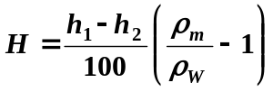, m of water

2. Theoretical discharge (Q_{t}):
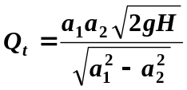, m³/s

3. Actual discharge (Q_{a}):
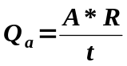 m³/s
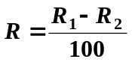
4. Co-efficient of discharge (C_{d}):
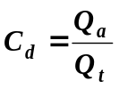
For Rotameter:
5. Actual discharge:
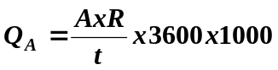 LPH
m

10. OBSERVATION & CALCULATIONS:
DATA:
A = 0.1 m²
ρ_{m} = 13600 kg/ m³
ρ_{W} = 1000 kg/ m³
g = 9.81 m/sec²
For Venturimeter:
d₁ = 0.028m
d₂ = 0.014m
a₁ = 6.157 * 10⁻⁴ m²
a₂ = 1.539* 10⁻⁴ m²
For Orificemeter:
d₁ = 0.028m
d₂ = 0.014m
a₁ = 6.157 * 10⁻⁴m²
a₂ = 1.539* 10⁻⁴m²

FOR VENTURIMETER
OBSERVATION TABLE:
S. No. | h₁  cm | h₂  cm | R₁  cm | R₂  cm | t  sec

CALCULATION TABLE:
S. No. | Q_{a} , m³/s | Q_{t} , m³/s | C_{d}

FOR ORIFICEMETER:
OBSERVATION TABLE:
S. No. | h₁  cm | h₂  cm | R₁  cm | R₂  cm | t  sec

CALCULATION TABLE:
S. No. | Q_{a} , m³/s | Q_{t} , m³/s | C_{d}

FOR ROTAMETER
OBSERVATION TABLE:
S.No. | Q_{R} LPH | R₁  cm | R₂  cm | t  sec

CALCULATION TABLE:
S. No. | Q_{R}, LPH | Q_{A}, LPH

11. NOMENCLATURE:

ρ_{m} = Density of manometer fluid (Hg), kg/m³

ρ_{w} = Density of water kg/m³

A = Area of Measuring Tank, m²

a₁ = Area at inlet of Venturimeter and orifice meter, m²

a₂ = Area at Throat of Venturimeter and Area of orifice, m²

C_{d} = Coefficient of discharge.

d₁ = Diameter at inlet of Venturimeter & orifice meter, m

d₂ = Diameter at throat of Venturimeter & diameter of orifice, m

g = Acceleration due to gravity, m/s²

H = Loss of head in m of water.

h1, h2 = Level on manometer fluid in limbs of manometer, cm.

Q_{a} = Actual discharge, m³/s.

Q_{A} = Actual discharge from rotameter, LPH

Q_{R} = Rota meter reading, LPH

Q_{t} = Theoretical discharge, m³/s.

R = Rise of Water level in Measuring Tank, m.

R₁ = Final level of water in measuring tank, cm.

R₂ = Initial level of water in measuring tank, cm.

t = Time taken for Rise of water level in measuring tank, sec

12. PRECAUTION & MAINTENANCE INSTRUCTIONS:
- Do not run the pump at voltage less than 180 and above 230 Volts.
- Never fully close the delivery line and by-pass line valves simultaneously.
- Always keep apparatus free from dust.
- To prevent clogging of moving parts, run pump at least once in a fortnight.
- Always use clean water.

13. TROUBLESHOOTING:
- If pump gets jammed, open the back cover of pump and rotate the shaft manually.
- If pump gets heat up, switch off the main power for 15 minutes and avoid closing flow control valve and by pass valve simultaneously during operation and also check main supply, it should be in the specified range.

14. REFERENCES:
- Modi P.N., Seth S. M., “Hydraulics And Fluid Mechanics Including Hydraulics Machines”, 15th ed., 2005.

EXPERIMENT - 6

AIR FLOW STUDIES BY PITOT TUBE

- OBJECTIVE:
To measure the flow velocity by use of a pitot static tube.

- AIM:
To measure velocity / flow using Pitot tube.

- INTRODUCTION:

When a fluid is flowing through a circular conduit, the velocity is given by dividing the volumetric flow rate by the area of cross section of the conduit. This velocity is the Average or Mean velocity of the fluid through the conduit. Actually the velocity of the fluid is not the same at all points in the pipe. Whether the flow is laminar or turbulent, the velocity is the maximum at the axis of the pipe and tapers off to zero at the wall of the pipe.

Pitot tube is used for determining the local velocity at various points in a pipe. It consists of an impact tube, which is positioned perpendicular to the direction of flow and a static tube, which is positioned parallel to the direction of flow. One end of the manometer is connected to the impact tube and the other end to the static tube. The resultant difference in manometer level indicates the difference between the sum of kinetic and pressure heads registered by the impact tube and the pressure head as registered by the static tube

h_{m} = h_{m1} – h_{m2}
V = √ 2 * g * h
Where h = h_{m} (ρ_{m} - ρ_{a})/ ρ_{a}

The velocity V is point velocity and not the average velocity. It is the velocity corresponding to the position of impact tube.
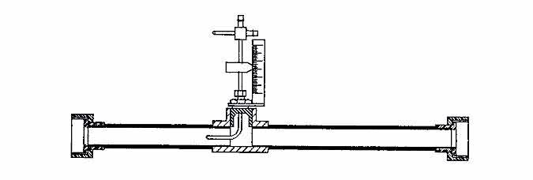
Figure:1 Pitot Tube Arrangement

THEORY

Pitot tubes were invented by Henri Pitot in 1732 to measure the flowing liquid or air velocity. Basically a differential pressure (d/p) flowmeter, a pitot tube measures two pressures: the static and the total impact pressure. The static pressure is the operating pressure in the pipe, duct, or the environment, upstream to the pitot tube. It is measured at right angles to the flow direction, preferably in a low turbulence location. The total impact pressure (PT) is the sum of the static and kinetic pressures and is detected as the flowing stream impacts on the pitot opening. To measure impact pressure, most pitot tubes use a small, sometimes L-shaped tube, with the opening directly facing the oncoming flow stream. The point velocity of approach (VP) can be calculated by taking the square root of the difference between the total pressure (PT) and the static pressure (P) and multiplying that by the C/D ratio, where C is a dimensional constant and D is density:
Vp = C(PT - P)½/D

- APPARATUS DESCRIPTION:
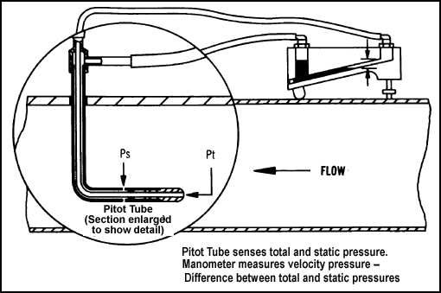

P_{s}=Static Pressure

Pt=Impact Pressure

The equipment comprises a long smooth walled Perspex pipe connected to the suction of an electrically driven centrifugal blower motor.
Air enters the smooth walled pipe through one of the End of pipe. Boundary layer growth is determined by the measurement of the velocity profile at different stations along the pipe using a traversing Pitot tube. A Pitot tube is traversed vertically and horizontally at different distances from the discharge orifice to investigate the dispersion properties.
Pressure measurements are made on an inclined cum vertical manometer mounted on the support frame. Pitot tube with static pressure tap and dynamic pressure tap is placed in the pipe with a flexibility to travel across the cross section of the tube. The impact and static end of the tube are connected to a manometer. Provision is made to vary the distance of the impact tube and to measure its distance from the center of the tube through which the fluid flows.
The equipment is mounted on a floor standing steel frame with an adjustable support for the extended suction pipe.
- PROCEDURE:

- Make 3 Φ electric connections to the blower.
- Select suitable position for measuring the air velocity profile and place the pitot tube in position.
- Measure the distance from the suction end of the pipe.
- Adjust the position of the impact tube at the center of the pipe.
- Connect the manometer tapping to the static pressure end only.
- Switch ON the motor of the blower using the starter.
- Adjust the position of the impact tube at a definite position in pipe.
- Connect the respective tapping’s to the Pitot tube and Manometer.
- Initially keep the manometer in vertical position & then adjust its inclination to obtain better accuracy of the measurement.
- Take readings for at least 10 different positions of the Pitot tube, five on either side of the central axis of the pipe.
- Repeat the above for different locations in the pipe.

- TECHNICAL SPECIFICATIONS:

Test pipe:
MOC = Acrylic
Diameter = 94 mm
Pitot tube:
MOC = SS-304
Range = 300 mm
Manometer:
Type = Adjustable Inclined cum Vertical combined
MOC = solid acrylic block
Range = 0 – 500 mm
Manometric Fluid = Water (Sp.Gr. = 0.998)

- FORMULA:

- Actual Manometer Reading (h_{v}) = h_{m1} * Min. Div. * (ρ_{water -} ρ_{air} / ρ_{air)} *10⁻³ m
- Air Velocity (V) = 0.98 * (m/s)
- Air Volumetric Flow rate (Q) = V * A m³/s
- Air Mass Flow rate = Q * ρ_{air} kg/s

- OBSERVATION :

- Inside Diameter of Pipe (d) = 94 mm =0.094 m
- Area of Cross Section of pipe (A) = m²
- Pitot tube Stations from End:
1) 400 2) 1000 3) 1600 4) 2200
- Density of water ρ_{water} = 1000 kg/m3
- Density of air ρ_{air} = 1.205 kg/m3
- Inclination of Manometer =
- Minimum division to be read on Inclined cum Vertical Manometer:
RANGE | INCLINATION | MIN. DIV.
0-500 mm WG | 1:1 | 1 mm
0-250 mm WG | 1:2 | 0.5 mm
0-100 mm WG | 1:5 | 0.2 mm
0-50 mm WG | 1:10 | 0.1 mm
0-25 mm WG | 1:20 | 0.05 mm

- OBSERVATION TABLE:

Area of the test pipe = | Density of water (Manometer liquid) = | Density of air = |  | 9
 |  |  |  | 8
 |  |  |  | 7
 |  |  |  | 6
 |  |  |  | 5
 |  |  |  | 4
 |  |  |  | 3
 |  |  |  | 2
 |  |  |  | 1
Area of the test pipe = | Density of water (Manometer liquid) = | Density of air = | Pitot tube Station Distance from the end (mm) | Position of Impact tube | Distance from the Center of the pipe R (mm) | Manometer Reading (h_{m1}) (mm) in water column | Inclination of Manometer | Min. Div. | Actual Manameter h_{v} , (mm) in air column | Air Velocity V = 0.98 * (m/s)

- CALCULATION:

- GRAPH:

Plot a graph between Velocity Vs Distance from the center of the pipe .

- APPLICATIONS:

EXPERIMENT - 7

CENTRIFUGAL PUMP TEST RIG

1. OBJECTIVE:
Study of centrifugal pump characteristics

2. AIM:
- To determine:
      - Total head
      - Discharge
      - Pump Output
      - Overall efficiency
      - Pump efficiency
- To plot the following performance characteristics:
      - Head Vs Discharge.
      - Pump efficiency Vs Discharge.

3. INTRODUCTION:
The hydraulic machines, which convert the mechanical energy into hydraulic energy, are called pumps. The hydraulic energy is in the form of pressure energy. If the mechanical energy is converted into pressure energy by means of centrifugal force acting on the fluid, the hydraulic machine is called centrifugal pump.

- THEORY:
Centrifugal pump:
Centrifugal Pump is a mechanical device, which consists of a body, impeller and a rotating mean i.e. motor, engine etc. Impeller rotates in a stationary body and sucks the fluid through its axes and delivers through its periphery. Impeller has an inlet angle, outlet angle and peripheral speed, which affect the head and discharge. Impeller is rotated by motor or i.c. engine or any other device.
The centrifugal pump acts as a reversed of an inward radial flow reaction turbine. This means that the flow in centrifugal pumps is in the radial outward directions. The centrifugal pump works on the principle of forced vortex flow, which means that an external torque rotates a certain mass of liquid, the rise in pressure head of the rotating liquid takes place. The rise in pressure head at any point of the rotating liquid is proportional to the square of tangential velocity of (i.e. rise in pressure head = V²/ 2g or ω²r²/2g) the liquid at that point. Thus at the outlet of the impeller where radius is more, the rise in pressure head will be more and the liquid will be discharged at the outlet with a high- pressure head. Due to this high-pressure head, the liquid can be lifted to a high level.
5. DESCRIPTION:
Centrifugal Test Rig consists of a sump tank, a centrifugal pump, a DC motor and measuring tank. To measure the head, pressure and vacuum gauges are provided. To measure the discharge, a measuring tank is provided. Flow diversion system is provided to divert flow from sump tank to measuring tank and from measuring tank to sump tank. A valve is provided in pipeline to change the flow rate.

6. UTILITIES REQUIRED:
Electric Supply: Single Phase, 220 V AC, 50 Hz, 5 Amp.
Water Supply (Initial Fill)

Drain Required.
Floor Area Required: 2 m x 1 m

7. EXPERIMENTAL PROCEDURE:
Starting Procedure:
- Clean the apparatus and make all tanks free from dust.
- Close the drain valve provided.
- Fill sump tank ¾ with clean water and ensure that no foreign particles are there.
- Open flow control valve given on the water discharge line and control valve given on suction line.
- Ensure that all On/Off Switches given on the panel are at OFF position.
- Now switch on the main power supply and switch on the pump.
- Set the desired RPM of pump with the speed control knob provided on the control panel.
- Operate the flow control valve to regulate the flow of water discharged by the pump.
- Operate the control valve to regulate the suction of the pump.
- Record discharge pressure by means of pressure gauge, provided on discharge line.
- Record suction pressure by vacuum gauge, provided at suction of the pump.
- Record the power consumption by energy meter, provided in panel by measuring time for 10 or 20 pulses with stopwatch.
- Measure the discharge by using measuring tank and stopwatch.
- Repeat the same procedure for different discharge with constant speed.
- Repeat the same procedure for different speeds of pump.
- Repeat the procedure for reciprocating pump.
Closing Procedure:
- When experiment is over, open gate valve provided on the discharge line.
- Reduce the RPM of the pump to zero.
- Switch OFF the pump.
- Switch OFF Power Supply to panel.
- Drain all the tanks.

8. SPECIFICATIONS:
Pump : Single phase, 1HP, 2800 RPM.
Sump Tank : Material SS.
Flow Measurement : Using Measuring Tank & Stop Watch.
Pressure Gauge : Bourdon type, 0-2 kg/cm².
Vacuum Gauge : Bourdon type, 0-760 mm Hg.
Control Panel Comprises of :
RPM measurement : Digital RPM Indicator with Proximity sensor.
Energy measurement : L&T make, Electronic Energy meter.
MCB : For overload protection.
Standard make On/Off Switch, Mains Indicator, etc.
All tanks are made of Stainless Steel.
The whole set-up is well designed and arranged in a good quality painted structure.

9. FORMULAE:
1. Input Power,
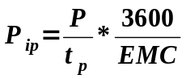
2. Shaft Power,
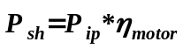
3. Discharge,

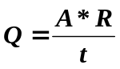
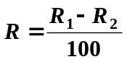

4. Total Head,

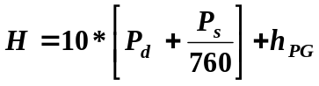
5. Output Power,
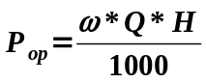

6. Overall efficiency,
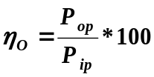
7. Pump efficiency,
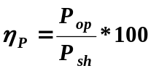

10. OBSERVATION & CALCULATION:
DATA:
EMC = 3200 Pulses/kW-hr.
A = 0.128 m².
ω = 9810 kg /m²-sec².
η_{motor} = 0.8.
h_{PG} = 1 m.

OBSERVATION TABLE:
S. No. | N | P_{d},  kg /cm² | P_{s},  mm Hg | R₁,  cm | R₂,  cm | t,  sec | P | t_{p},  sec
1 | 1450 | 0 | 99 | 10 | 23 | 10 | 8 | 42
2 | 1462 | 0.05 | 90 | 20 | 32.5 | 10 | 8 | 42
3 | 1467 | 0.1 | 88 | 20 | 30 | 10 | 8 | 43
4 | 1472 | 0.15 | 48 | 20 | 28.4 | 10 | 8 | 45
5 | 1480 | 0.18 | 25 | 20 | 32.8 | 10 | 8 | 49
6 | 1480 | 0.2 | 11.1 | 20 | 32.2 | 10 | 8 | 53

S. No. | N | P_{d},  kg /cm² | P_{s},  mm Hg | R₁,  cm | R₂,  cm | t,  sec | P | t_{p},  sec
1 | 1600 | 0.25 | 11.1 | 10 | 21.7 | 10 | 6 | 35
2 | 1603 | 0.2 | 42 | 20 | 27.9 | 10 | 6 | 29
3 | 1603 | 0.15 | 55 | 20 | 30.8 | 10 | 6 | 27
4 | 1605 | 0.1 | 80 | 20 | 32.6 | 10 | 6 | 26
5 | 1606 | 0.05 | 111.1 | 20 | 34 | 10 | 6 | 25
6 | 1608 | 0 | 133.3 | 20 | 35 | 10 | 6 | 25

CALCULATION TABLE:
S. No. | Q  m³ /s | H  m | P_{ip},  kW | P_{sh},  kW | P_{op}, kW | η_{p}  % | η_{o}  %
1 | 0.00166 | 2.3 | 0.214 | 0.1714 | 0.037 | 21.92 | 17.5
2 | 0.0016 | 2.68 | 0.214 | 0.1714 | 0.042 | 24.57 | 19.6
3 | 0.00128 | 3.15 | 0.209 | 0.167 | 0.039 | 23.6 | 18.94
4 | 0.00107 | 3.13 | 0.2 | 0.16 | 0.033 | 20.64 | 16.51
5 | 0.00163 | 3.12 | 0.183 | 0.146 | 0.05 | 34.22 | 27.38
6 | 0.00156 | 3.14 | 0.169 | 0.135 | 0.048 | 35.47 | 28.38

S. No. | Q  m³ /s | H  m | P_{ip},  kW | P_{sh},  kW | P_{op}, kW | η_{p}  % | η_{o}  %
1 | 2e-4 | 3.64 | 0.192 | 0.154 | 0.007 | 5.04 | 4.03
2 | 0.001 | 3.55 | 0.232 | 0.186 | 0.035 | 18.9 | 15.14
3 | 0.0013 | 3.22 | 0.25 | 0.2 | 0.043 | 21.85 | 17.48
4 | 0.0016 | 3.05 | 0.259 | 0.207 | 0.048 | 23.25 | 18.6
5 | 0.00179 | 2.96 | 0.27 | 0.216 | 0.052 | 24.10 | 19.28
6 | 0.00192 | 2.75 | 0.27 | 0.216 | 0.051 | 24.01 | 19.21

11. NOMENCLATURE:
ω = Specific Density of water, kg /m²-sec².
η_{p} = Pump efficiency.
η_{o} = Overall efficiency.
η_{motor} = Efficiency of motor.
A = Area of Measuring tank, m².
EMC = Energy Meter Constant, pulses/kW-hr.
H = Total Head, m.
h_{PG} = Height of pressure gauge from suction of the pump, m.
N = Speed of Pump, RPM.
P = Pulses of energy meter.
P_{ip} = Input Power, kW.
P_{sh} = Shaft Power, kW.
P_{op} = Output Power, kW.
P_{d} = Discharge Pressure, kg/cm².
P_{s} = Suction Pressure, mm of Hg.
Q = Discharge, m³/s.
R = Rise of water level in measuring tank, m.
R₁ = Final height of water in measuring tank after time t, cm.
R₂ = Initial height of water in measuring tank, cm.
t = Time for R, sec
t_{p} = Time for P pulses, sec

12. PRECAUTIONS & MAINTENANCE INSTRUCTIONS:
- Do not run the pump at Voltage less than 180 and above 230 Volts.
- Never fully close delivery valve and suction valve.
- Always use clean water.
- Always keep apparatus free from dust.
- To prevent clogging of moving parts, run pump at least once in a fortnight

13. TROUBLESHOOTING:
- If pump does not lift the water, open the air vent provided on the pump to remove the air from pump.
- If still water is not lifting the revolution of the DC motor may be reverse. Interchange Red wire connection of motor to change the revolutions.
- If panel is not showing input, check main supply.
- If field failure (FF) indicates on the control panel and the motor not moving, check the fuses if burnt, change it.
- If overload (OL) indicates on the panel and motor stop moving, reduce the load on the pump by opening the discharge valve. Switch OFF the main power supply, wait for one minute and then start again.

14. REFERENCES:
- Mathur, Sharma & Purohit, “Fluid Mechanics & Fluid Machines”, 2nd ed., Satya Prakashan, ND, 1982.
- Sarao A.S., Khosla D.S.,”Hydraulics & Hydraulic Machines”, 4th ed., Satya Prakashan, ND, 1988.
- BhattacharyaS.C., Dubs R.,”Hydraulic Machines”, 4th ed., Metropolitan Book Co., ND, 1970.
- Bansal R.K., “Fluid Mechanics & Hydraulic Machines”, 5th ed., Luxmi Publications, ND, 1995.

